
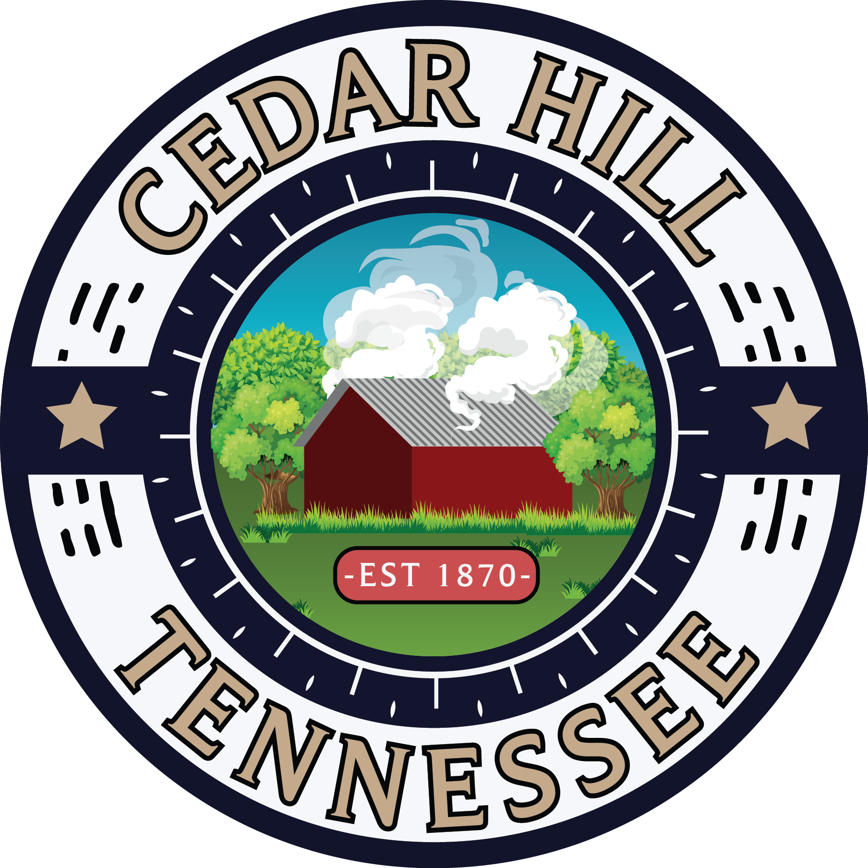

2023 growth plan
Contents
Introduction 2
Community Snapshot 2
Demographics 2
Population Projections 3
Income 3
Housing 3
Education 4
Map: Regional context 5
Map: local context 6
Existing Land Use 7
Existing Land Use Map 8
Percentage of total acreage used for each land use designation 9
Number of Parcels of Each Land Use Designation 9
Natural Resources 10
Wetlands 11
Hydrology of Cedar Hill 12
Flood Risk 13
Public Facilities & Services 13
Potable Water System 13
Wastewater 13
Electricity 13
Solid Waste 13
Future Land Use 13
Future Land Use Map 14
Percentage of total acreage used for each land use designation 15
Number of Parcels of Each Land Use Designation 15
Goals, Objectives, and Policies 16
Goal 1: Establish Future Land Use Categories 16
Goal 2: Land Use and Community Character 16
Goal 3: Land Use Compatibility 16
Goal 4: Explore the Creation of a Town Center 17

Cedar Hill Growth Plan

Introduction
The following Growth Plan, consistent with the Tennessee Growth Policy Act (Public Chapter 1101, Acts of 1998), outlines the current conditions of the City of Cedar Hill and projects opportunities for growth management and land use patterns. Cedar Hill has a long history of agriculture, community, and quality rural living – a history that’s important to protect and support through informed land use planning. This plan serves as a guiding document for the future growth and development of Cedar Hill, reinforced by the outlined goals, objectives, and policies.

Community Snapshot
Cedar Hill is a small, rural city located in Northwest Robertson County just 45 minutes from Nashville. According to the US Census Bureau, Cedar Hill has an estimated population of around 350 residents. Population projections show minor decline over the next 5 years for Cedar Hill at -3.7% but expect the county to grow at +2.5% and the state to grow at +2.8%. Cedar Hill is a young town with a strong middle-class population, with an average age of 28.8 years and around 65% of households earning more than $50,000 annually.
It’s important to note that survey methods used by ESRI and the U.S. Census Bureau have a larger margin for error when calculating statistics for cities with small populations like Cedar Hill. This should be considered when evaluating projections of population loss considering the growth Robertson County and the State of Tennessee is experiencing.

Demographics
Gender | Count
Male | 181
Female | 167
Total | 348
Source: American Community Survey 2021, U.S. Census Bureau
Race | Count
White | 336
Black or African American | 12
American Indian and Alaska Native | 5
Asian | 2
Some other race | 2
Total | 348
Source: American Community Survey 2021, U.S. Census Bureau
Age | Count
Under 5 years | 40
5 to 9 years | 20
10 to 14 years | 25
15 to 19 years | 28
20 to 24 years | 46
25 to 34 years | 54
35 to 44 years | 35
45 to 54 years | 43
55 to 59 years | 19
60 to 64 years | 12
65 to 74 years | 13
75 to 84 years | 8
85 years and over | 5
Total | 348
Median Age (years) | 28.8
Source: American Community Survey 2021, U.S. Census Bureau

Population Projections
Site | 2023 Total Population | 2028 Total Population
Cedar Hill City, TN | 297 | 286 (-3.7%)
Robertson County, TN | 75,605 | 77,507 (+2.5%)
Tennessee | 7,120,037 | 7,317,991 (+2.8%)
USA | 337,470,185 | 342,640,129 (+1.5%)
Source: Esri Business Analyst Online

Income
Household Income Level | Percentage of Total Households
Less than $10,000 | 2.2%
$10,000 to $14,999 | 4.4%
$15,000 to $24,999 | 8.8%
$25,000 to $34,999 | 12.1%
$35,000 to $49,999 | 7.7%
$50,000 to $74,999 | 17.6%
$75,000 to $99,000 | 19.8%
$100,000 + | 27.4%
Total | 100
Source: ESRI Business Analyst Online

Housing
The City, like most in Tennessee, is primarily made up of detached single-family homes on large lots (70.2%) – a housing style important to the character of Cedar Hill and reinforced through the goals, objectives, and policies of this growth plan. There is a large presence of manufactured homes as well in Cedar Hill, a housing type important to retaining affordability in the market. According to the American Community Survey published by the U.S. Census Bureau, Cedar Hill has an approximate 114 housing units with an average home value of $175,135.

Total Households: 108
Total Housing Units: 114

Average value of units with a mortgage: $175,135
Average value of units without a mortgage: $93,429

Type of Housing Unit | Number of Units | Percentage
Single family detached | 80 | 70.2%
Mobile Home | 34 | 29.8%
Total: | 114 | 100%
Source: American Community Survey 2021, U.S. Census Bureau

Education
Population 25+ by Educational Attainment | Number | Percentage
No Schooling | 1 | 0.6
5th to 8th Grade | 2 | 1.2%
Some High School | 12 | 7.5%
High School Diploma | 57 | 35.4%
GED | 19 | 11.8%
Some College | 31 | 19.3%
Associate degree | 9 | 5.6%
Bachelor’s Degree | 17 | 10.6%
Master’s Degree | 9 | 5.6%
Professional School Degree | 2 | 1.2%
Total: | 161 | 100%
Source: ESRI Business Analyst Online

Map: Regional context
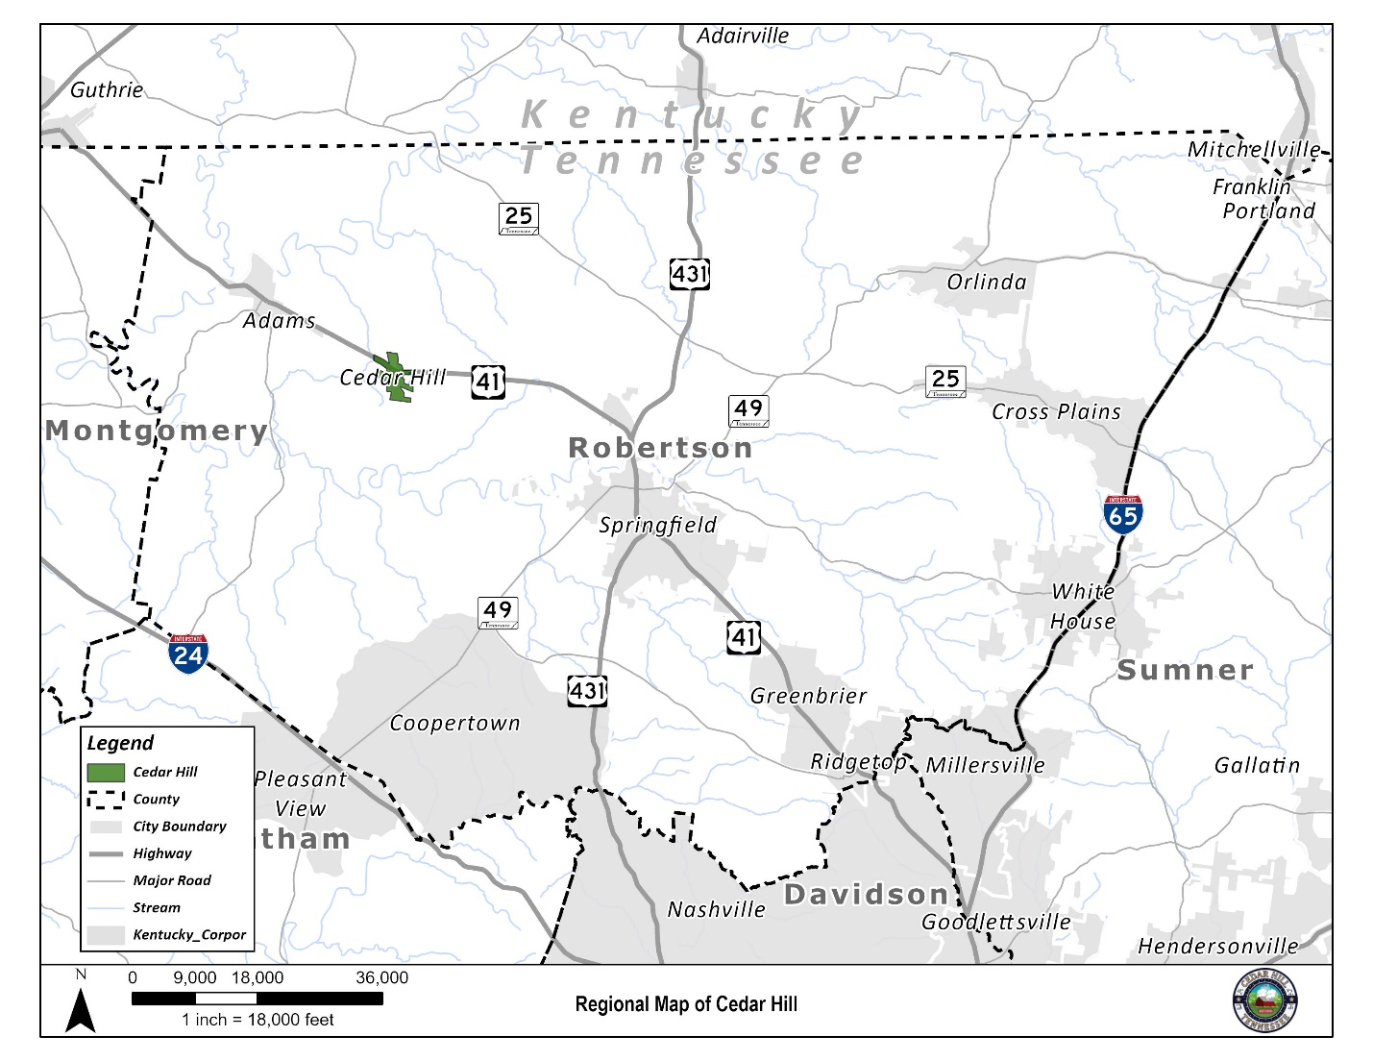

Map: local context
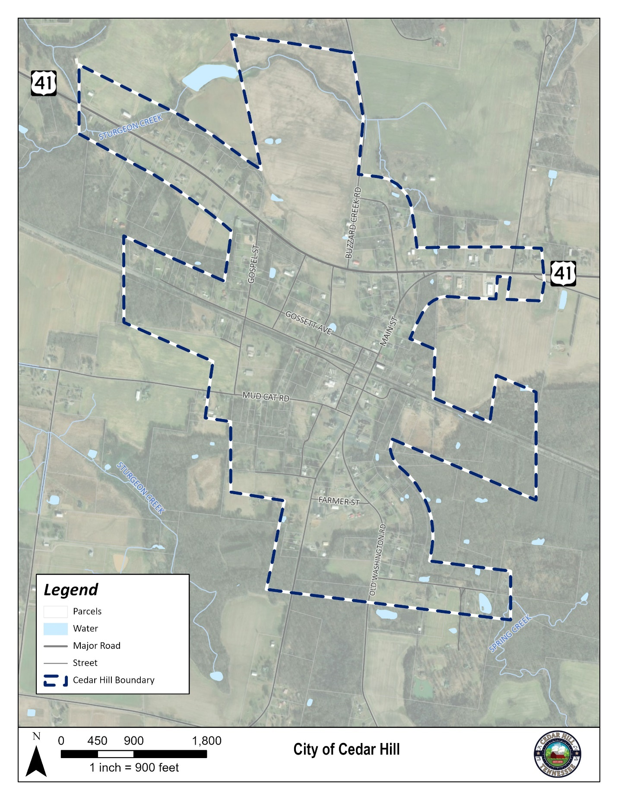

Existing Land Use
Land use describes the management and allocation of land for various uses within Cedar Hill’s municipal boundary. These uses are tracked as agriculture, residential, commercial, public/institution, conversation, or vacant. It’s important to track how land is used, conserved, and developed by the community to best monitor environmental health, housing availability, and economic activity. Most land in Cedar Hill is used for Agricultural or Residential uses, making up over 80% of the total land area. There are also significant portions of Cedar Hill that are set aside for conservation under the ownership of the state of Tennessee. The remaining land is either commercial business or public/institutional for City buildings or places of worship. The accompanying map visualizes these uses.

Existing Land Use Map
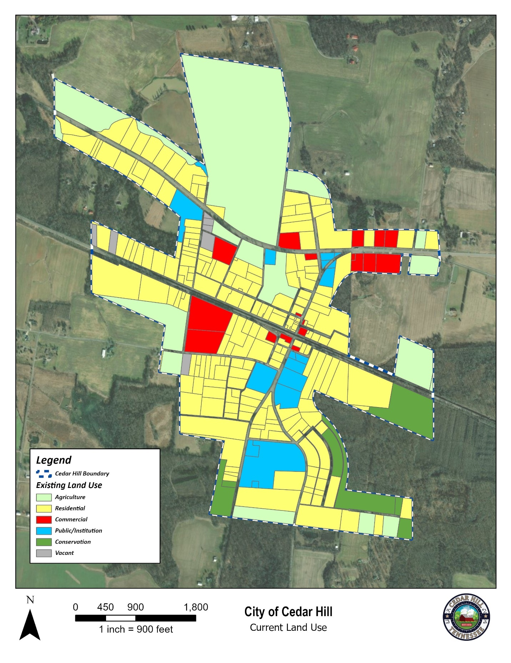

Percentage of total acreage used for each land use designation:

Number of Parcels of Each Land Use Designation:

Natural Resources
Cedar Hill and its residents hold the resources and beauty of our natural environment in high regard. It’s essential for the land use of the community to reflect this priority and continue the agricultural and rural history of the City. The City has only a few wetlands and streams that run through its municipal limits, but they are important to the region’s ecosystem nonetheless.
The following maps label the streams and wetlands within Cedar Hill.

Wetlands
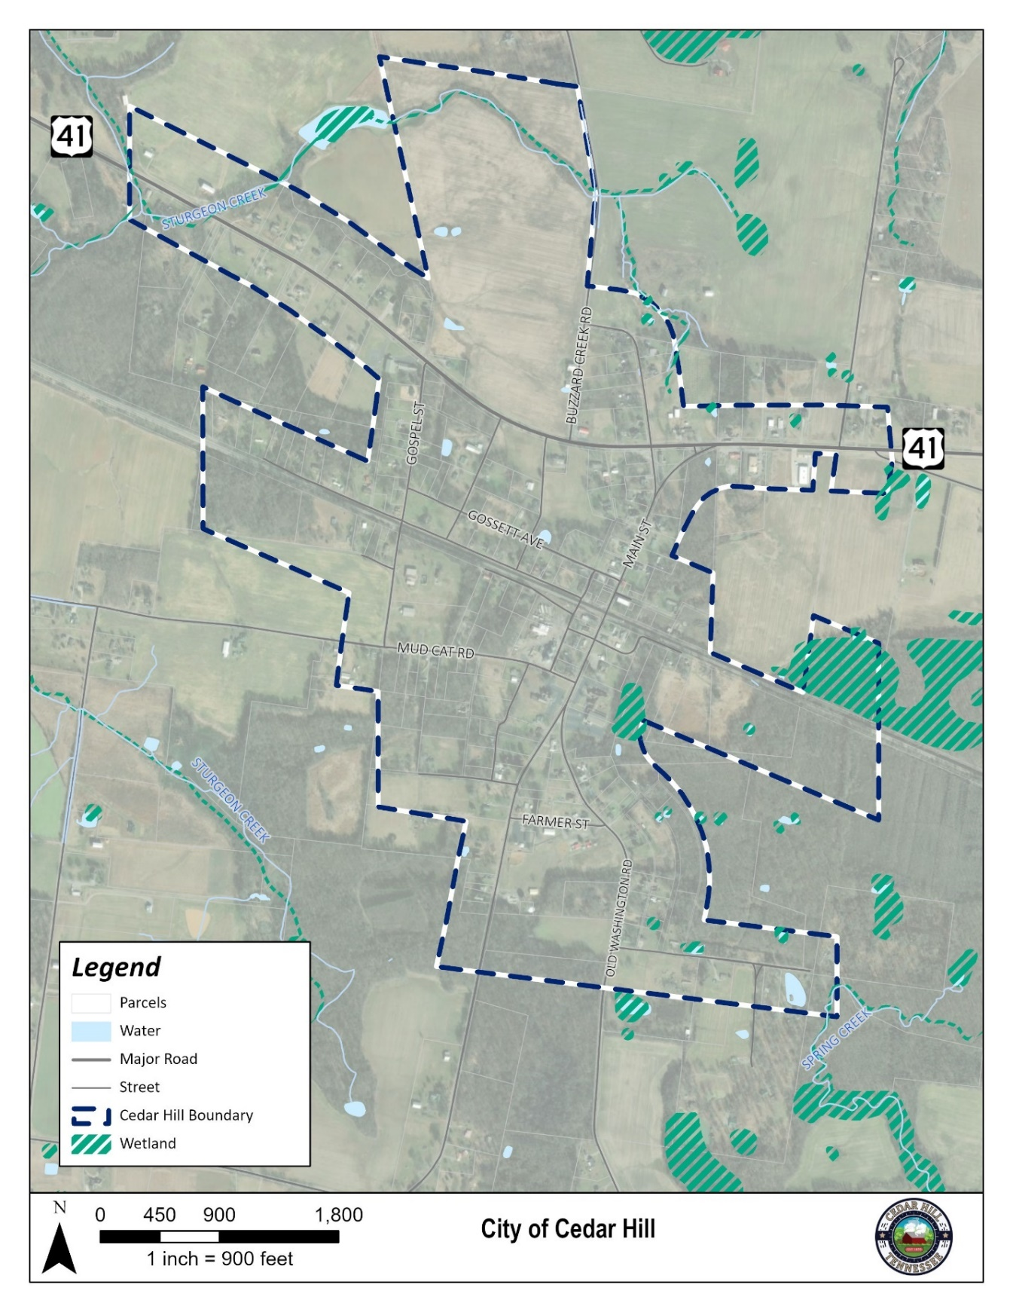

Hydrology of Cedar Hill
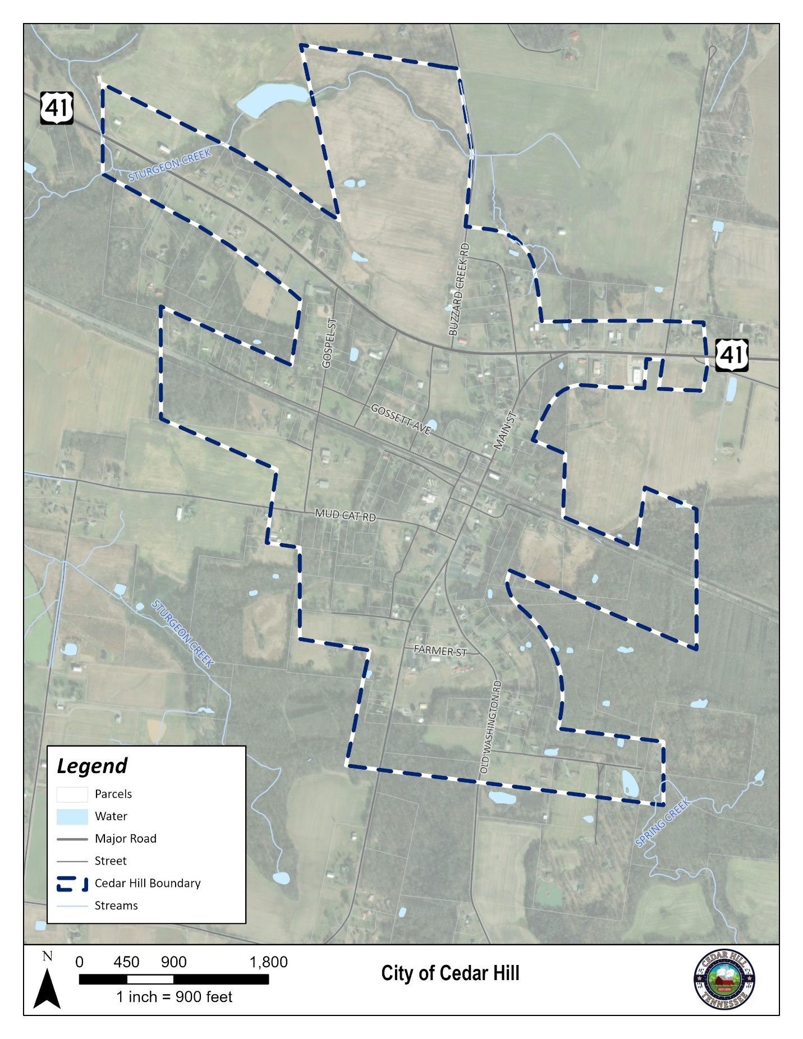

Flood Risk
The City of Cedar Hill does not have significant flood risk. The Federal Emergency Management Agency (FEMA) designates flood risk areas into a variety of classes. The entirety of Cedar Hill is designated as X-Unshaded meaning an area of minimal flood risk usually above the 500-year flood plain.

Public Facilities & Services

Potable Water System
West Robertson Water Authority (WRWA) provides potable water to the City of Adams and Cedar Hill. WRWA’s service area also extends north of Red River and south of Sulphur Fork to service approximately 1,600 customers within the entire service area. With a total capacity of 600,000 gallons per day, the water treatment plant is located on Keysburg Road in the City of Adams. Three water storage tanks are located throughout the service area with one of the storage tanks having a capacity of 300,000 gallons. All potable water for this utility provider is drawn from the Red River with emergency connections to Springfield and Clarksville water systems available when needed. The Springfield water system connection is located off Kinney Road in Cedar Hill and the Clarksville connection is located on Ed Jones Road in the Saddlerville community. These emergency connections were added due to the need to search for a long-term protection against reduced flow and water quality of the Red River.

Wastewater
The majority of homes, businesses, and farms utilize on-site septic systems for wastewater needs. The City of Cedar Hill has an agreement with Tennessee Wastewater/ Adenus to serve residents and businesses who chose to access this private wastewater system. Those who use this service must pay to run lines to the main line, a connection fee, and monthly charges for the service. There are some businesses and homes that utilize the private wastewater line, however due to capacity the City expects to remain primarily on-site septic for the foreseeable future.

Electricity
Cedar Hill’s electricity needs are fulfilled locally by the CEMC (Cumberland Electric Membership Corporation). The Tennessee Valley Authority (TVA) provides flood control, navigation, and land management for the Tennessee River system, and assists utilities and state and local governments with economic development.

Solid Waste
Robertson County Solid Waste Department (RCSW) operates a Transfer Station and Recycling Center for residents and businesses in Robertson County. There are seven convenience center locations throughout the county, with one of those seven in Cedar Hill. Located at 308 South Main Street, Cedar Hill, residents can safely dispose of bagged household garbage and recycle cardboard and newsprint materials. Items such as motor oil, batteries, paint, and electronics must be disposed of at the main Transfer Station and Recycling Center. In conjunction with the State of Tennessee, RCSW also provides a Household Hazardous Waste Collection Day once a year for residents to dispose of items such as chemicals, pesticides, herbicides, and other hazardous waste.

Future Land Use
Future Land Use gives Cedar Hill an opportunity to develop the guiding blueprint for the future of the City and its development. With that being said, the City and its residents enjoy the development patterns and uses that have occurred organically over the years and plan to model its future uses accordingly. The City aims to retain its commercial uses along Highway 41, bolstering the economic activity of the corridor through infill and develop vacant parcels with agricultural and residential development. The accompanying map and figures outline this plan and the land areas affected.
Future Land Use Map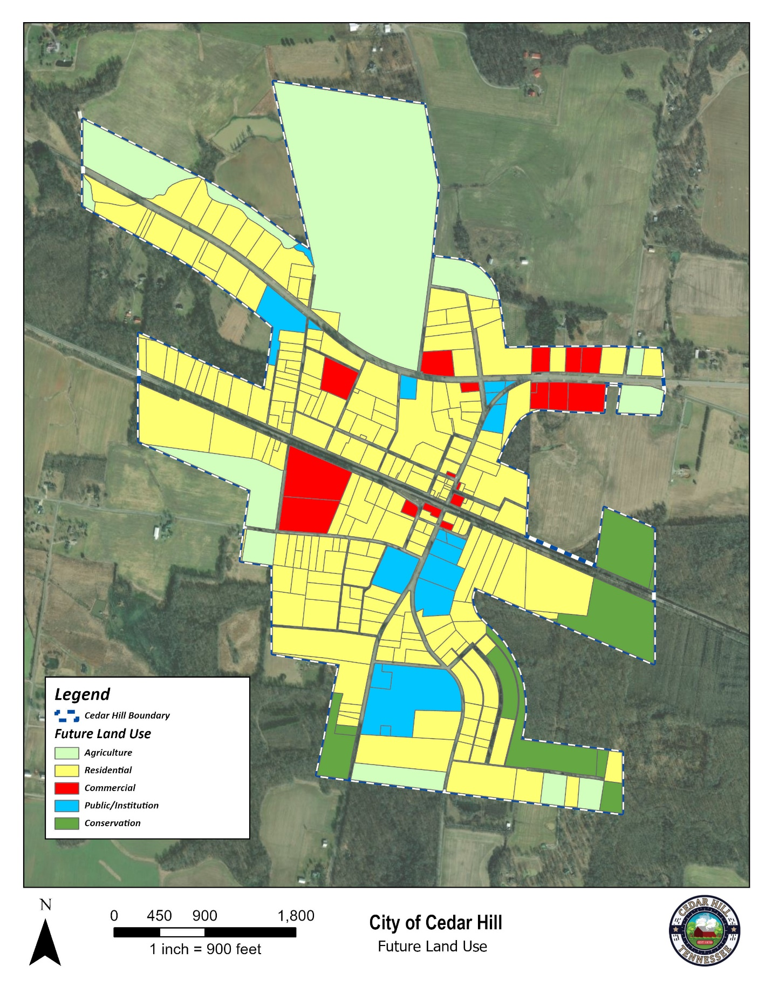

Percentage of total acreage used for each land use designation:

Number of Parcels of Each Land Use Designation:

Goals, Objectives, and Policies

Goal 1: Establish Future Land Use Categories
The following land use categories, which are depicted on the Future Land Use Map, are hereby established to provide varying degrees of environmental protection and levels of development.
Future Land Use Category | Maximum Density or Lot Size
Agriculture | 1 Dwelling Unit Per 2 Acres
Residential | 1 Dwelling Unit/Acre
Commercial | 20,000 Sq. Ft. (minimum)
Public/Institution | 5,000 Sq. Ft. (minimum)
Conservation | N/A
Policy 1.1 Agriculture: The purpose of the agriculture land use category shall be to protect farmlands from development and protect natural resource values.
Policy 1.2 Residential: Land designated to best accommodate single-family residential development on existing parcels or subdivisions.
Policy 1.3 Commercial: Land best used for the buying, trading, or selling of commercials goods and services.
Policy 1.4 Public/Institution: Land designated to benefit the City though public utility services, government offices, places of worship, or public recreation facilities.
Policy 1.5 Conservation: Undeveloped land left undisturbed to protect natural habitat, wildlife, and viability.

Goal 2: Land Use and Community Character
Promote a mixture of land uses that preserves agricultural land and rural character while concentrating development within identified cores.
Policy 2.1: The future land use map depicts current recreation/open space areas. Future facilities may be located within any of the other land use categories without having to amend the plan.
Policy 2.2: Encourage infill and revitalization in identified centers to capitalize on existing streets, services and buildings instead of creating a need for new infrastructure and buildings.
Policy 2.3: Building Height should follow a step-down approach, with buildings decreasing in height as they move away from low-density neighborhoods and transition to Agricultural areas.
Policy 2.4: Review the land development regulations to ensure development along Highway 41 is not promoting strip or big box commercial development.
Policy 2.5: The land development regulations should manage the location and types of signs to avoid interference with traffic flow and sight distance and preserve scenic and agrarian landscape and community character.
Policy 2.6 Ensure that the current agricultural lands identified on the Future Land Use map are maintained to limit: adversely affecting adjacent rural areas, increasing traffic, and substantially degrading the overall scenic values and community character of the community.

Goal 3: Land Use Compatibility
Land development regulations should utilize techniques and development standards to achieve a functional and compatible land use framework that preserves agricultural lands, open space, and the traditional land use pattern of Cedar Hill.
Policy 3.1: Buffering and landscape standards should be included in the City’s land development regulations to protect various types of development from the impact of others.
Policy 3.2: The City should direct development to areas where services and facilities currently exist with a focus on infill development.
Policy 3.3: The preservation of Agricultural areas within Cedar Hill is necessary in order to maintain compatibility. Therefore, the existing Agricultural areas along on 41N that are adjacent to the rural areas setback from 41N should continue to remain agricultural.

Goal 4: Explore the Creation of a Town Center
A potential Town Center should serve as a central area with a mix of retail, office, commercial, institutional, governmental facilities and housing that serves as a gateway to the community and provides a central local for community activities and needs.
Policy 4.1: Consider developing a centralized commercial area for the City and its residents.
Policy 4.2: Ensure that new commercial development with a Town Center is designed with pedestrians in mind, providing safe, attractive, and convenient linkages within the Town Center.
Policy 4.3: Development within the Town Center should fit within the scale and character of the City’s rural identity.
Policy 4.4: A Town Center should maximize the potential of existing lots, utilities, and structures through infill or retrofitting where possible, rather than developing on undisturbed parcels.
Policy 4.5: A Town Center should connect to the Town’s park system to encourage walkability and connectivity.

